In 2022, the following performance of crypto currency is being revealed.

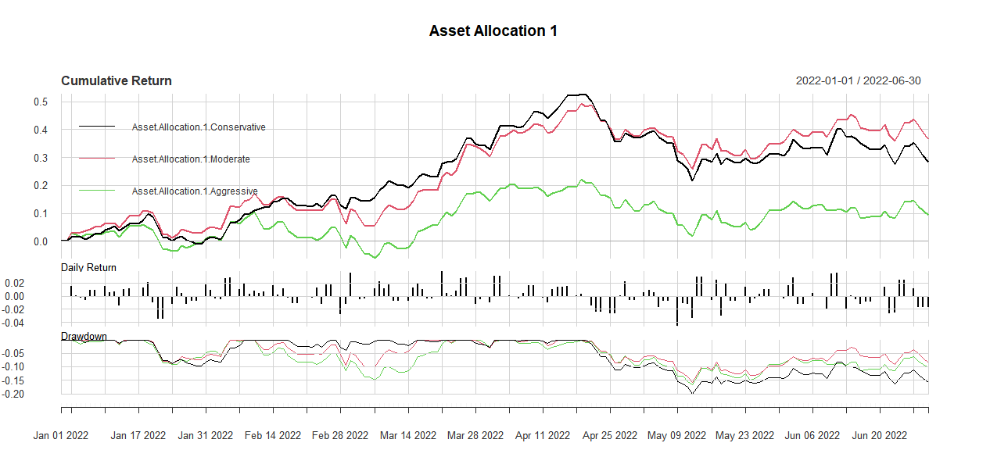

Stock market was performing well in this time period as we are seen the moderate strategy is performing and returning best returns.

|  |  |  |  |  |  |
| --- | --- | --- | --- | --- | --- |
|  | Sharp | Sortino | VaR | Skewness | Kurtosis |
| Conservative | 1.75812 | 0.1541919 | -0.02320157 | -0.06435888 | 0.354061 |
| Moderate | 2.089989 | 0.1797063 | -0.02441503 | 0.0944693 | 0.3731653 |
| Aggressive | 0.5167137 | 0.05644247 | -0.02621584 | -0.01382118 | 0.1083698 |

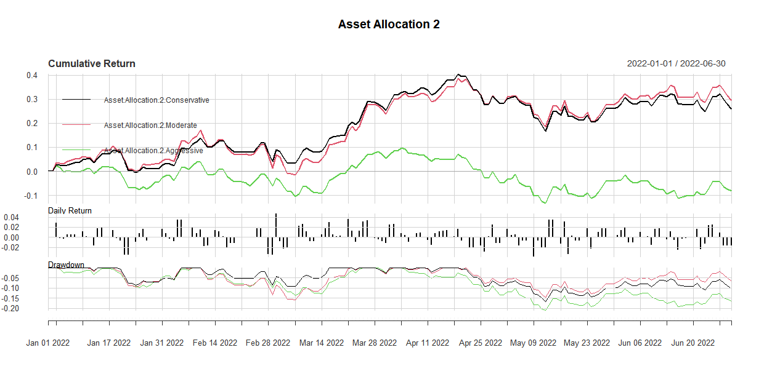

In this again the aggressive strategy was performing well because the funds allocated to this have minimum gold in them and that is why, although the return was low but NASQAD and Treasury after 2021 start yielding results.

|  |  |  |  |  |  |
| --- | --- | --- | --- | --- | --- |
|  | Sharp | Sortino | VaR | Skewness | Kurtosis |
| Conservative | 1.525256 | 0.137639 | -0.02382948 | 0.04949897 | 0.2714085 |
| Moderate | 1.556147 | 0.1383034 | -0.02685573 | 0.02529395 | 0.4264034 |
| Aggressive | -0.435594 | -0.02925283 | -0.02709185 | -0.04186117 | -0.1488684 |

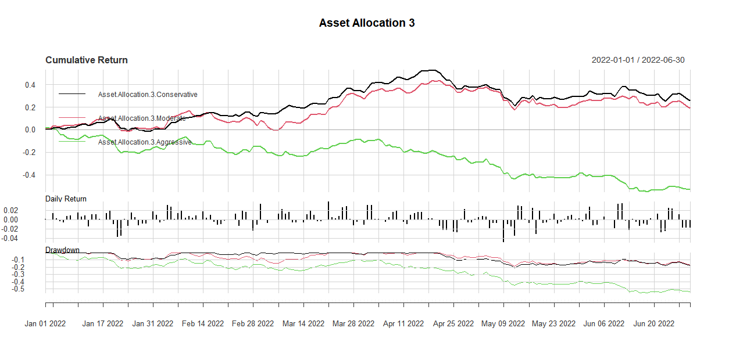

In this strategy, maximum amount of returns have been assigned to aggressive strategy and that is why the return from this strategy has been so much greater than anyone in the time frame of two years. Because of the hypothesis, there is a negative relation between crypto currency and stock market and that is what we are witnessing.

|  |  |  |  |  |  |
| --- | --- | --- | --- | --- | --- |
|  | Sharp | Sortino | VaR | Skewness | Kurtosis |
| Conservative | 1.566662 | 0.1386134 | -0.02380904 | -0.1233291 | 0.4829177 |
| Moderate | 0.9424052 | 0.09017073 | -0.02933128 | -0.1357028 | 0.632331 |
| Aggressive | -1.584977 | -0.1765902 | -0.04998117 | -0.6085458 | 0.9104246 |

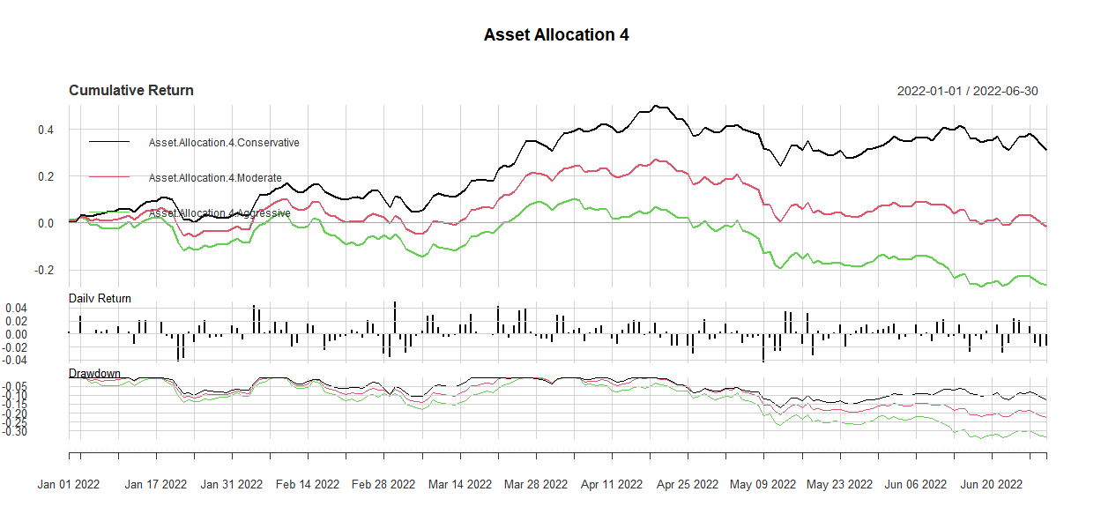

In this again, aggressive is returning the maximum results and the ratios are also calculated as:

|  |  |  |  |  |  |
| --- | --- | --- | --- | --- | --- |
|  | Sharp | Sortino | VaR | Skewness | Kurtosis |
| Conservative | 1.734202 | 0.151835 | -0.02539077 | 0.02707449 | 0.4219753 |
| Moderate | -0.07771583 | 0.005294181 | -0.03046644 | -0.3716503 | 0.8521704 |
| Aggressive | -1.048906 | -0.08892542 | -0.03906377 | -0.5902807 | 0.9555977 |

# Conclusion

In the year 2022, Stock market was performing well and the return from crypto. Because of Ukraine and Russia war there is a drop of stock performance can be seen and then the crypto start giving returns.